A Project Report
On
Resume Analyzer System
A project submitted in partial fulfillment of Project VI of VI semester



Submitted To:
Faculty of Science and Technology
Purbanchal University
Biratnagar, Nepal

Submitted By:
Alok Jha
Jayant Joshi
Pramod singh

Aryan School of Engineering and Management
Mid-Baneshwor, Devkota Sadak, Nepal
July, 2025

Aryan School of Engineering and Management
Devkota Sadak, Mid Baneshwor



Project Report
On
Resume Analyzer System
A Project Report Submitted in partial fulfillment of requirement for the Degree of Bachelor in Information Technology (BIT)

Submitted By:
ALOK JHA(360200)
JAYANT JOSHI(360206)
PRAMOD SINGH (360209)

Submitted To:
Supervisor: Mr. Rojil Shrestha
Faculty of Science and Technology
July, 2025

Declaration
We hereby declare that the project report entitled “Resume Analyzer System” is a result of our own original work done during the academic session 2024/25. This report has not been submitted to any other institution for any purpose.

Signature: _______________
Name: Alok Jha
Sy. No.: 360200
Date: July, 2025

Signature: _______________
Name: Jayant Joshi
Sy. No.: 360206
Date: July, 2025

Signature: _______________
Name: Pramod Singh
Sy. No.: 360209
Date: July, 2025

Certificate of Project Approval
It is hereby certified that the project report entitled “Resume Analyzer System” is a creditable and original study that has been carried out and presented in a satisfactory manner by Alok Jha, Jayant Joshi and Pramod Singh. This report has been submitted in partial fulfillment of the requirements for the award of the degree.
In granting this approval, the undersigned acknowledge that they are not necessarily endorsing the conclusions or opinions expressed in the report, but are approving it solely for the purpose it was intended.

(Internal Examiner) (External Examiner)

Head of Department

Certification from Supervisor
This is to certify that the project entitled “Resume Analyzer System” is a bonafide work carried out by the following students in partial fulfillment of the requirements for the degree of Bachelor of Information Technology (BIT) under Purbanchal University during the academic session 2024/25.
This project work has been carried out under my supervision and is hereby approved as a part of the curriculum.

Project Supervisor:
Signature:
Name: Mr. Rojil Shrestha
Date: July, 2025

Acknowledgement
We would like to express our heartfelt gratitude to Mr. Er. Sunil Kumar Ram, our Head of Department, for his invaluable guidance, encouragement, and continuous support throughout this project. His insights and mentorship were instrumental in shaping the direction and execution of our work.
We are sincerely thankful to Mr. Rojil Shrestha, our respected project supervisor, for his consistent supervision, thoughtful suggestions, and timely feedback, which greatly enhanced the quality of our project.
We also extend our appreciation to our friends for their immense support whether moral, technical, or logistical which played a crucial role in the successful completion of this project.
Finally, we are grateful to all our faculty members and mentors who provided direction and inspiration during this academic journey.
Thank you
Sincerely,
Alok Jha
Jayant Joshi
Pramod Singh

Abstract
In today’s competitive job market, presenting a well-structured and relevant resume is critical to securing employment. Traditional resume screening methods are often manual, time-consuming, and subject to bias, while existing online tools offer limited features and often require a paid subscription. To address these limitations, this project introduces an Resume Analyzer System that leverages Machine Learning (ML) and Natural Language Processing (NLP) to intelligently evaluate resumes and provide actionable feedback.
The main objective of this system is to help users—especially fresh graduates and job seekers, optimize their resumes by identifying strengths, weaknesses, and skill gaps. It further enhances user experience by offering career path recommendations based on the extracted data and includes an interactive chatbot assistant for real-time support.
The system is developed as a full-stack web application using React.js for the frontend, Node.js and Express.js for the backend, MongoDB as the database, and Python for AI model integration. The resume parsing, analysis, and career suggestion features are handled by a trained ML model with text preprocessing, keyword extraction, and skill-matching logic.
The final output of the system includes:
- A secure user dashboard with resume upload
- Automated analysis with visual feedback
- Skill and career recommendations
- Resume history and chatbot support
This project offers a free, accessible, and intelligent platform to improve resume quality, enhance employability, and support users in achieving their career goals.

Table Of Content
Acknowledgement IV
Abstract V
Chapter 1: Introduction 1
1.1 Resume Analyzer System Overview 1
1.2 Objectives 2
1.2.1 General Objectives 2
1.2.2 Specific Objectives 2
1.3 Problem Statement 3
1.4 Application 4
1.5 Project Features 4
1.6 Scope and Limitations 5
1.6.1 Scope of the Resume Analyzer system 5
1.7 Tools and Technologies Used 6
1.7.1 Programming Languages 6
1.7.2 Frontend Technologies 6
1.7.3 Backend Technologies 6
1.7.4 AI/ML & NLP Tools 6
1.7.5 Database 7
1.7.6 Other Technology 9
Chapter 2: System Analysis 10
2.1 Requirement Gathering 10
2.1.1 Functional Requirements 10
2.1.2 Non-Functional Requirements 11
2.2 Feasibility Study 12
2.2.1 Technical Feasibility 12
2.2.2 Economic Feasibility 12
2.2.3 Operational Feasibility 12
2.2.4 Legal Feasibility 13
2.2.5 Schedule Feasibility 13
2.3 Existing System 13
2.3.1 Manual Screening 13
2.3.2 Traditional Applicant Tracking Systems (ATS) 13
2.3.3 Limited Free Online Tools 14
2.4 Proposed System 14
2.5 Use Case Diagram 15
Chapter 3: System Design 17
3.1 System Architecture 17
3.2 Flowchart (Resume Analyzer System) 17
3.3 Work Schedule 19
3.3 Database Design 20
3.4 UI/UX Design 20
Chapter 4: System Development and Implementation 21
4.1 Modules Description 21
4.1.1 User Authentication Module 21
4.1.2 Resume Upload Module 21
4.1.3 Resume Parsing & Extraction Module 21
4.1.4 AI-Based Resume Analysis Module 22
4.1.5 Career Recommendation Module 22
4.1.6 Result Visualization Module 22
4.1.7 Chatbot Module 23
4.1.8 Resume History & Report Module 23
4.2 Backend Logic 23
4.2.1 User Authentication (JWT & Bcrypt) 23
4.2.2 Resume Upload and Parsing 24
4.2.3 AI Model Integration (Python + Flask) 24
4.2.4 Result Storage & Retrieval 24
4.2.5 Chatbot Backend Logic 24
4.2.6 API Routes Summary 25
4.2.7 Security Features 25
Chapter 5: Testing and Results 26
5.1 Testing Methods 26
5.1.1 Unit Testing 26
5.1.2 Integration Testing 26
5.1.3 Functional Testing 27
5.1.4 UI/UX Testing 27
5.1.5 Security Testing 27
5.1.6 Usability Testing 27
5.1.7 Performance Testing 28
5.2 Bugs Fixed or Known Issues 28
5.2.1 Bugs Fixed 28
5.2.2 Known Issues / Limitations 29
5.3 Output Screens 29
5.3.1 Landing Page 29
5.3.2 Registration Page 30
5.3.3 Login Page 31
5.3.4 User Dashboard 32
5.3.5 Resume Upload Page 33
5.3.6 Resume Analysis Result Page 34
5.3.7 Visual Graphs and Charts 35
5.3.8 Chatbot Assistant Window 36
5.3.9 Resume History Page 37
Chapter 6: Conclusion and Future Scope 38
6.1 Summary 38
6.2 Limitations 38
6.3 Future Enhancements 38
References 39
Appendices 40

Table of Figures
Fig 1.7.5: Class Diagram 8
Fig 2.5: Use Case Diagram 16
Fig 3.2: Flow chart of the system 18
Fig 3.3: Work Schedule 19
Fig 5.3.5: Landing Page 29
Fig 5.3.6: User registration page 30
Fig 5.3.7: Login page 31
Fig 5.3.8: User dashboard 32
Fig 5.3.9: Resume upload page 33
Fig 5.3.10: Resume analysis result page 34
Fig 5.3.11: Graph 35

Chapter 1: Introduction

1.1 Resume Analyzer System Overview
The AI-Powered Resume Analyzer System is an intelligent web-based application designed to analyze resumes submitted by users and provide insightful feedback using machine learning and natural language processing (NLP) techniques. The system helps job seekers understand the strengths and weaknesses of their resumes by offering career suggestions, skill recommendations, and identifying irrelevant or outdated content.
The primary goal of this project is to bridge the gap between job seekers and employers by improving resume quality and aligning candidates' skills with market demand. Users can upload their resumes (PDF or text format), and the system will automatically extract and analyze key information such as education, experience, skills, and projects.
The system also includes a chatbot assistant that answers resume-related queries and provides career guidance. Furthermore, visual charts are generated to represent skill relevance and domain fit.
This application was built using modern technologies such as Python (for AI model and backend processing), React.js (frontend), Node.js (backend API), and MongoDB (database). Machine learning models were trained on real-world resume and job data to provide accurate and personalized results.
This project not only demonstrates the practical implementation of AI in recruitment but also serves as a useful tool for students and professionals to improve their resumes and increase their employability.

1.2 Objectives
The main objective of this project is to develop a smart and user-friendly system that assists users in improving their resumes and identifying suitable career paths through AI-driven analysis. The system aims to bridge the gap between resume quality and job market expectations by providing automated insights and guidance.

1.2.1 General Objectives
- To design and implement a web-based application that uses Artificial Intelligence (AI) and Natural Language Processing (NLP) to analyze resumes.
- To assist users in enhancing their resumes and receiving personalized career guidance based on their qualifications and skills.
- To ensure secure and seamless access to the system for all users.

1.2.2 Specific Objectives
- Resume Upload and AI-Based Analysis:
Build a secure system that enables users to upload resumes in PDF or DOCX format and extract relevant data such as skills, education, and experience using NLP techniques.
- Personalized Career Guidance:
Use machine learning models to predict the most suitable career domains based on resume content and provide personalized suggestions for skill development.
- User Authentication and Secure Access:
Implement a secure registration and login system using JWT (JSON Web Tokens) to protect user data and restrict unauthorized access.
- Skill Gap Identification:
Identify missing, outdated, or irrelevant skills in the resume and recommend improvements to better align with current job market trends.
- User-Friendly Interface:
Design an intuitive and responsive web interface that allows users to easily upload resumes, view results, and navigate the system.
- Chatbot Integration:
Develop a basic chatbot that can answer resume-related questions and guide users in improving their documents.
- Data Visualization:
Present analysis results in visual formats such as bar charts, pie charts, or graphs to make the feedback easy to understand.
- Robust Error Handling and Offline Support:
Ensure smooth user experience through proper error validation (e.g., file type checks, empty inputs, invalid tokens) and allow the system to function locally without requiring continuous internet access.

1.3 Problem Statement
In today’s competitive job market, thousands of candidates apply for the same position, and a well-structured, relevant resume plays a crucial role in getting shortlisted. However, many job seekers, especially fresh graduates, lack the knowledge of how to present their skills and experiences effectively. Their resumes often contain irrelevant information, outdated skills, or are not aligned with the job roles they are applying for.
Recruiters, on the other hand, face challenges in manually going through large volumes of resumes, which is time-consuming and inefficient. There is a growing need for an automated system that can assist both candidates and recruiters by analyzing resumes accurately and offering valuable feedback. Hence, there is a need for an intelligent system that:
- Analyzes the content of resumes using AI.
- Identifies strengths and weaknesses.
- Recommends suitable career paths.
- Suggests improvements for better job market alignment.
The Resume Analyzer System addresses this gap by providing users with detailed analysis, skill recommendations, and personalized career suggestions using machine learning and natural language processing.

1.4 Application
The Resume Analyzer system can be applied in several practical and educational contexts. Key uses include:
- Educational Tool: Used in colleges and training centers to teach students how resumes are evaluated and how AI and NLP can enhance career guidance.
- Career Counseling: Assists counselors in analyzing students’ resumes and providing data-driven suggestions for skill development and job readiness.
- Student Portfolio Evaluation: Helps institutions and students evaluate academic and extracurricular achievements in relation to desired career paths.
- HR & Recruitment Simulation: Provides a risk-free environment to simulate resume screening processes and evaluate AI’s role in recruitment workflows.
- Prototype for Career Platforms: Acts as a foundation for developing or enhancing AI-powered career guidance platforms or resume optimization tools.
- Offline Resume Analysis: Supports resume feedback in low-resource environments where internet access is limited, using a fully local system.

1.5 Project Features
The Resume Analyzer system offers a set of intelligent and interactive features designed to simplify resume evaluation and career guidance. Key features include:
- Resume Upload: Users can securely upload resumes in PDF or DOCX format for analysis.
- Skill and Experience Extraction: The system extracts key skills, education, experience, and relevant keywords using Natural Language Processing (NLP).
- Career Domain Prediction: Based on resume content, the system predicts suitable career fields and roles for the user.
- Learning Gap Identification: Detects missing skills or qualifications and suggests areas for improvement or further learning.
- User Dashboard: Provides each user with a dashboard showing recent analyses, statistics, and insights.
- Secure Login and Access: Uses JWT-based login system to ensure secure, role-based access to resume data.
- Secure Access: Implement secure login and role-based access controls to ensure that only authorized users can modify or view inventory data.
- Reporting Generation: Generates downloadable PDF reports summarizing analysis results and recommendations.
- Offline Functionality: Designed to run entirely on a local machine without internet, ideal for classrooms or restricted environments.
- Error Handling and Validation: Handles errors like unsupported file formats, missing fields, or invalid inputs with proper alerts and guidance.

1.6 Scope and Limitations

1.6.1 Scope of the Resume Analyzer system
- Resume Upload and Analysis:
Users can upload resumes in PDF or text format, which are then automatically analyzed using AI techniques.
- Skill Extraction and Evaluation:
The system extracts key information such as skills, education, work experience, and projects to assess the resume's quality.
- Career Recommendations:
Based on the extracted data, the system recommends suitable career paths and relevant job roles.
- Improvement Suggestions:
Users receive suggestions to remove outdated or irrelevant skills and add trending skills as per current job market demand.
- Chatbot Support:
A built-in chatbot answers resume-related questions and guides users through career-related decisions.
- Data Visualization:
Graphs and charts are generated to visualize resume strengths, skill relevance, and domain fit.
- Modern Tech Stack:
Developed using Python (AI), React (frontend), Node.js (backend), and MongoDB (database), providing a scalable and responsive system.

1.7 Tools and Technologies Used
The project utilizes a combination of modern programming languages, frameworks, libraries, and tools to develop an efficient, responsive, and intelligent resume analysis system. Below is a breakdown of the major technologies used:

1.7.1 Programming Languages
- Python:
Used for developing the AI model, natural language processing, and backend logic.
- JavaScript:
Used for frontend interactivity and backend logic through Node.js.

1.7.2 Frontend Technologies
- React.js:
A JavaScript library used to build the interactive and responsive user interface.
- Bootstrap / Tailwind CSS:
Used for styling and designing a clean, modern UI.
- Chart.js / Recharts:
For displaying graphical insights and skill analysis.

1.7.3 Backend Technologies
- Node.js:
Server-side runtime used to handle API requests and route communication between frontend and backend.
- Express.js:
Lightweight web application framework for building APIs and routing.

1.7.4 AI/ML & NLP Tools
- Scikit-learn:
Used for building and training the machine learning model.
- Pandas / NumPy:
For data manipulation and preprocessing.
- Natural Language Toolkit (NLTK) / spaCy:
For extracting text, tokenizing, and analyzing resume content.

1.7.5 Database
The class diagram represents the structure of a resume analysis system with six main classes: User, Resume, Analysis, AnalysisHistory, Chat, and UserContext. The User class holds personal and professional details and is connected to multiple resumes, chats, and analysis histories. The Resume class stores information about uploaded files and belongs to a user, while the Analysis class captures insights extracted from each resume, such as skills, experience, and learning gaps. The AnalysisHistory class tracks each analysis event with relevant metrics and timestamps. The Chat class records interactions between the user and the system, and UserContext maintains personalization settings and conversation history to enhance user experience. This structure ensures efficient data organization and supports personalized and scalable resume analysis.

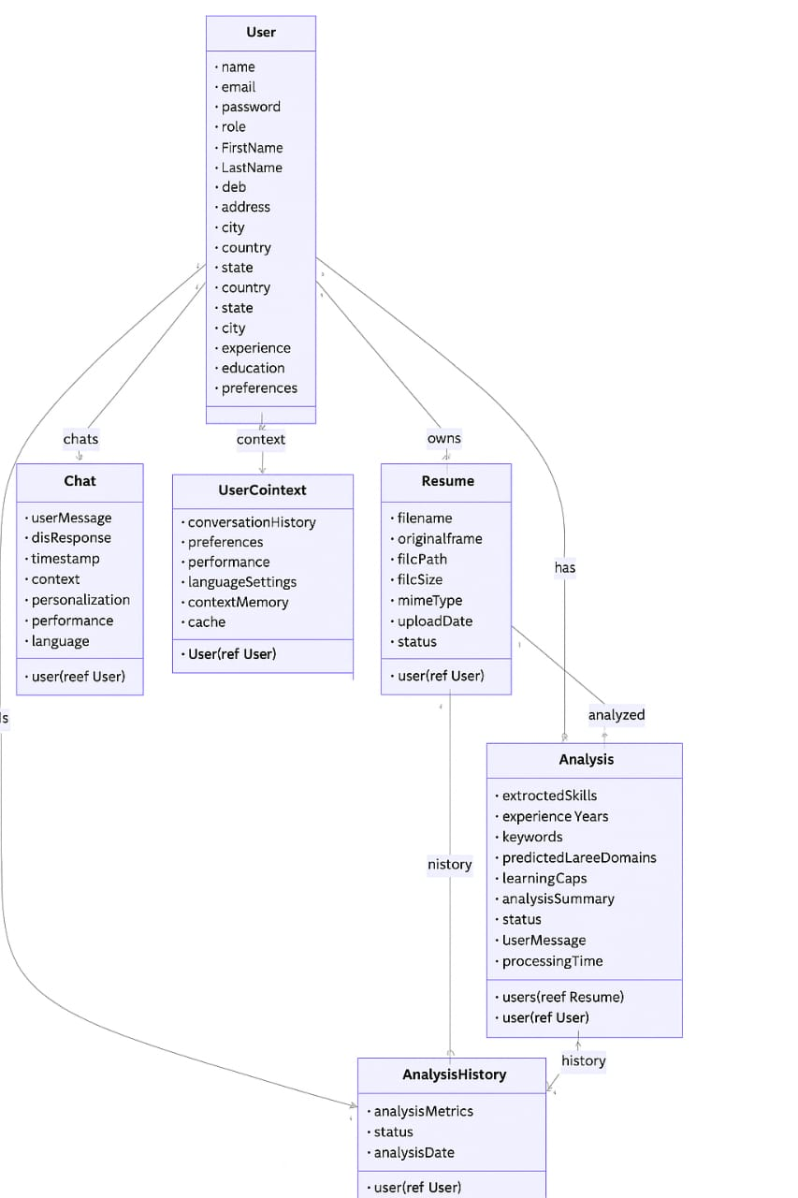
Fig 1.7.5: Class Diagram

1.7.6 Other Technology
- JWT (JSON Web Token):
For secure user authentication and session handling.
- Bcrypt.js:
To hash user passwords securely.
- Postman:
For API testing during development.
- Git & GitHub:
For version control and collaborative development.

Chapter 2: System Analysis

2.1 Requirement Gathering
Requirement gathering is a crucial phase in software development where the needs of users and the system are identified and documented. For the AI-Powered Resume Analyzer System, both functional and non-functional requirements were gathered to ensure a complete and usable system.

2.1.1 Functional Requirements
These are the features and functionalities the system must provide:
- User Registration and Login
Users must be able to register and securely log in to the system.
- Resume Upload
Users can upload their resumes in PDF or plain text format.
- Resume Parsing
The system should extract relevant information such as name, education, skills, experience, etc.
- AI-Based Analysis
The backend should analyze the resume using NLP and ML to generate insights.
- Career Recommendation
The system should suggest the best-fit career path based on the resume content.
- Skill Suggestion
Recommend new skills to add and identify outdated or irrelevant ones to remove.
- Chatbot Support
The chatbot should respond to common resume and career-related queries.
- Visual Reports
Display charts and graphs showing skill strength, domain fit, and improvement areas.
- Save and View History
Users should be able to view their previous analyses and uploaded resumes.

2.1.2 Non-Functional Requirements
These refer to the quality attributes of the system:
- Security:
User credentials must be securely stored using password hashing (bcrypt) and authenticated using JWT.
- Performance:
Resume analysis should be completed within a few seconds for a smooth user experience.
- Responsiveness:
The user interface should be responsive and work well on both desktop and mobile devices.
- Data Storage:
The system must store user data and analysis results in a secure and scalable database (MongoDB).
- Scalability:
The system should be capable of handling multiple users and large amounts of resume data.
- Maintainability:
Code should be modular and maintainable for future updates and enhancements.

2.2 Feasibility Study
A feasibility study evaluates the practicality of the proposed system based on various aspects such as technical, economic, operational, and legal factors. This helps determine whether the project is viable and worth implementing.

2.2.1 Technical Feasibility
The project is technically feasible as it uses widely available technologies such as:
- Python for AI/ML and resume parsing
- React.js for frontend development
- Node.js and Express.js for backend services
- MongoDB for data storage
All tools and libraries used (e.g., scikit-learn, NLTK, JWT, bcrypt) are open-source and well-documented. The system can be easily deployed on local servers or scaled to cloud infrastructure.

2.2.2 Economic Feasibility
The system is economically viable since:
- It uses free and open-source technologies.
- No need for paid APIs or commercial software.
- Development is done by students as part of their academic curriculum.
The only possible costs are related to optional deployment (e.g., domain/hosting), which is not mandatory for local use.

2.2.3 Operational Feasibility
The system is user-friendly and intended for:
- Job seekers to improve their resumes.
- Students to explore suitable careers.
- Institutions or platforms to assist with resume screening.
The chatbot and visual feedback make the system easy to use even for non-technical users.

2.2.4 Legal Feasibility
The project does not violate any legal regulations:
- It uses user data securely (with consent).
- Data is not shared with third parties.
- Passwords are encrypted and authentication is handled securely using JWT and bcrypt.

2.2.5 Schedule Feasibility
The project was planned and developed within the academic timeline, with proper time allocated for:
- Research and model training
- Frontend and backend development
- Integration and testing
- Documentation

2.3 Existing System
Currently, most resume evaluation and career guidance services are either manual, paid, or limited to basic keyword-matching features. Traditional systems used by companies or job portals like LinkedIn, Indeed, or ATS (Applicant Tracking Systems) provide basic filtering based on keywords, but they have several limitations:

2.3.1 Manual Screening
- Recruiters or career counselors manually read and evaluate resumes.
- Time-consuming, especially when handling large volumes of applications.
- Prone to human error and bias.

2.3.2 Traditional Applicant Tracking Systems (ATS)
- Many companies use ATS software to filter resumes.
- These systems only scan for specific keywords or formats.
- Candidates with poor formatting or keyword use may be wrongly rejected.

2.3.3 Limited Free Online Tools
- Some online platforms allow users to analyze their resumes (e.g., Zety, Novoresume, ResumeWorded).
- However, most of these tools are:
- Limited in features without a paid subscription.
- Not based on advanced AI or machine learning.
- Do not offer personalized career suggestions or skill improvement tips.
- Lacking chatbot or interactive feedback mechanisms.
- Key Limitations of Existing Systems are :
- Lack of intelligent analysis using machine learning or NLP.
- No real-time feedback or interactive assistance.
- Limited support for non-standard resume formats
- Most tools are commercial and restrict full functionality for free users.

2.4 Proposed System
The proposed system, Resume Analyzer System, is an intelligent web-based application designed to overcome the limitations of traditional resume screening and manual career guidance. It uses advanced Machine Learning (ML) and Natural Language Processing (NLP) techniques to automatically analyze resumes and provide users with smart, data-driven suggestions.
Key Features of the Proposed System:
- Resume Upload and Parsing:
Users can upload their resume in PDF or text format. The system parses the file and extracts structured data like name, education, skills, experience, and projects.
- AI-Based Resume Analysis:
The system uses a trained ML model and NLP techniques to analyze the quality and relevance of the resume content.
- Career Path Recommendation:
Based on the resume content, the system suggests suitable job roles or domains aligned with the candidate's strengths.

- Skill Gap Detection:
It compares the user's skills with industry standards and recommends skills to learn or remove.
- Interactive Chatbot
A built-in chatbot assists users by answering queries related to resumes, careers, and improvements.
- Visual Feedback
The system generates charts and graphs showing strengths, weaknesses, and domain compatibility.
- Secure Login System
Users must register and log in using a secure authentication system with hashed passwords (bcrypt) and JWT-based token management.

2.5 Use Case Diagram
Here is the Use Case Description converted into bullet points:
- Register/Login:
User creates an account or logs into the system securely.
- Upload Resume:
User uploads a resume file (PDF or text).
- Analyze Resume:
System parses and analyzes the uploaded resume using AI/NLP techniques.
- View Report:
User views the analysis report, which includes strengths, weaknesses, and other insights.
- Get Career Suggestions:
System recommends suitable career paths based on the resume content.
- Skill Recommendation:
Suggests skills to add or remove for better alignment with job roles.
- Chatbot Support:
User interacts with a chatbot to get help related to resumes and careers.
- View History:
User can view and manage previously analyzed resumes.

- Logout:
User securely logs out from the system.

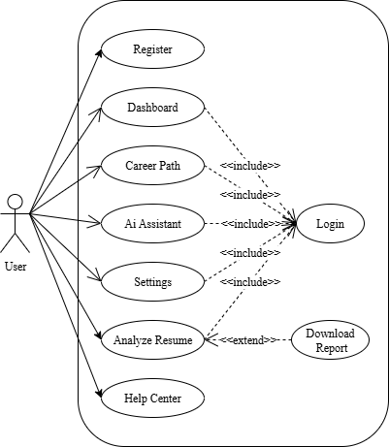
Fig 2.5: Use Case Diagram

Chapter 3: System Design

3.1 System Architecture
The System Architecture of SkillBridge illustrates the interaction between its core components: the frontend, built with React and Tailwind CSS, provides the user interface where users can register, log in, upload resumes, and view results. The backend, powered by Node.js and Flask, handles API communication, authentication, and resume analysis logic. Uploaded resumes are processed using NLP models (spaCy and NLTK) to extract relevant data. This information is stored and retrieved from a MongoDB database, which maintains user profiles, analysis history, and settings. The architecture ensures smooth, secure, and offline-capable functionality across all modules.

3.2 Flowchart (Resume Analyzer System)
The flow begins when the user accesses the Landing Page, which acts as the entry point to the SkillBridge platform. From here, users can either register a new account or log in if they already have one. After successful login, users are directed to the User Dashboard, where they can access all main features of the system. This includes uploading their resume for analysis, interacting with the AI Assistant, and exploring suggested career paths based on their extracted skills.
In addition to these features, users can visit the Settings section to update their profile or manage security preferences. Once a resume is uploaded, the system analyzes it using NLP techniques and allows users to generate a report that highlights key skills, relevant career domains, and any learning gaps that need attention. These personalized suggestions help guide users toward suitable professional growth paths.
Finally, after completing all actions, users can securely log out from the platform. This ends their session and redirects them out of the application, ensuring data security and completing the user flow. This structured design offers a smooth, intuitive experience while providing valuable career insights through AI-driven analysis.
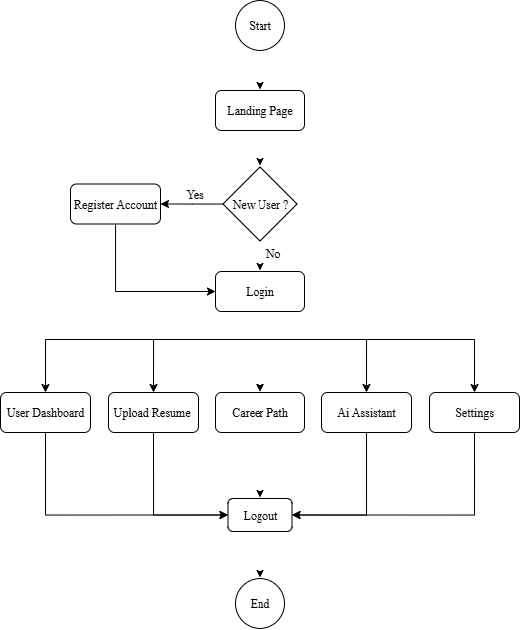
Fig 3.2: Flow chart of the system

3.3 Work Schedule
The Gantt chart for the Resume Analyzer System outlines a structured 6-week project timeline, highlighting the distribution of tasks across different phases. In Week 1 and 2, the focus is on Project Planning, ensuring that the objectives and scope are clearly defined. Simultaneously, System Design is initiated and completed by Week 2. From Week 3 to Week 5, Coding and Programming is carried out, laying the core functionality of the system. Prototype Development follows closely in Week 4 and 5, allowing the team to build and refine an early version of the product. Testing and Refinement takes place in Week 5 and 6, ensuring bugs are fixed and performance is optimized. A significant portion of Documentation and Reporting spans from Week 2 to Week 6, emphasizing the importance of recording progress and results. Lastly, Presentation Preparation is scheduled for Week 6, aiming to finalize deliverables and get ready for the final showcase or evaluation. This timeline ensures smooth progress and balanced task allocation throughout the development cycle.
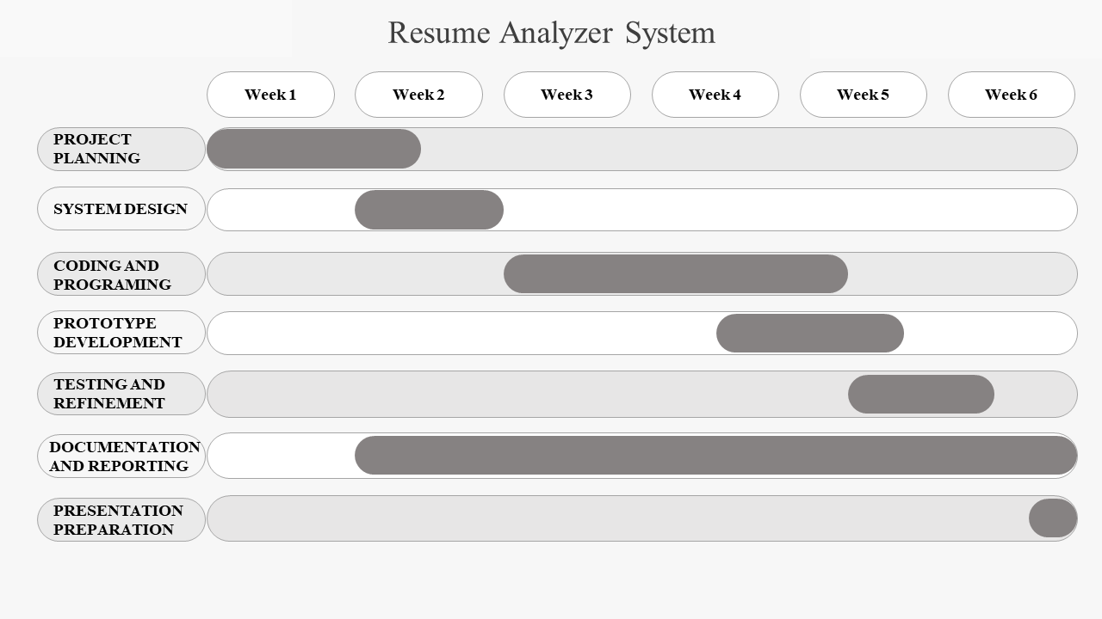
Fig 3.3: Work Schedule

3.3 Database Design
The SkillBridge system utilizes MongoDB, a NoSQL database that stores data in a flexible, JSON-like format known as documents within collections. This design allows for easy handling of unstructured resume data and dynamic user information. Key collections include: Users, which stores registration data, login credentials, and user roles; Resumes, which contains uploaded resume content, extracted skills, and analysis results; Career Suggestions, which maps user skills to relevant career domains; and History, which logs each user’s past resume uploads and reports. This structure ensures efficient storage, quick access, and scalability for future enhancements.

3.4 UI/UX Design
User Interface (UI) and User Experience (UX) design are critical components of this project to ensure ease of use, interactivity, and smooth navigation. The goal is to provide users—especially job seekers and students—with a clean, intuitive, and responsive platform for uploading, analyzing, and improving their resumes.

Chapter 4: System Development and Implementation

4.1 Modules Description
The Resume Analyzer System is divided into several functional modules that work together to perform resume analysis, skill evaluation, and career recommendation. Each module has a specific role in the system to ensure modularity, reusability, and clarity.

4.1.1 User Authentication Module
Description:
Handles user registration, login, logout, and authentication using JWT (JSON Web Tokens).
Features:
- Secure password hashing (using bcrypt)
- Login/session management
- Error handling (e.g., wrong credentials)

4.1.2 Resume Upload Module
Description:
Allows users to upload resumes in supported formats (PDF or text).
Features:
- Resume file selection and validation
- File storage or conversion to text
- Trigger resume parsing after upload

4.1.3 Resume Parsing & Extraction Module
Description:
Extracts structured data such as name, education, skills, experience, and projects from the uploaded resume using NLP techniques.
Technologies Used:
Python, spaCy, NLTK

4.1.4 AI-Based Resume Analysis Module
Description:
Applies ML algorithms to analyze resume quality, detect missing or irrelevant skills, and generate improvement suggestions.
Features:
- Skill match vs. market demand
- Strength and weakness detection
- Trend-based suggestions

4.1.5 Career Recommendation Module
Description:
Suggests best-fit job roles or domains based on extracted skills, education, and experience.
Features:
- Role matching with AI-trained data
- Top 3–5 suitable career paths
- Links to external job platforms (optional)

4.1.6 Result Visualization Module
Description:
Presents analysis results through charts and graphs for better understanding.
Tools:
Chart.js, Recharts
Features:
- Skill strength pie chart
- Skill gap bar graph
- Domain fit percentage

4.1.7 Chatbot Module
Description:
A user-friendly assistant that answers queries related to resume writing, skills, and career paths.
Features:
- NLP-powered question answering
- Suggested FAQs
- Human-like interaction

4.1.8 Resume History & Report Module
Description:
Maintains a record of users’ uploaded resumes and analysis results.
Features:
- View/download previous reports
- Track resume improvement over time

4.2 Backend Logic
The backend of the Resume Analyzer System is responsible for handling all server-side operations, including API requests, authentication, communication with the AI model, database management, and file handling. It is built using Node.js and Express.js, with Python integration for the AI model.

4.2.1 User Authentication (JWT & Bcrypt)
Registration Logic:
  - Accept user details (name, email, password).
  - Hash the password using bcrypt.
  - Store user data in the users collection.
Login Logic:
  - Accept email and password.
  - Compare entered password with the hashed password.
  - If valid, generate a JWT token for session management.

4.2.2 Resume Upload and Parsing
- Accepts resume files (PDF or text) from the frontend via POST API.
- Saves the file to server storage or converts to plain text.
- Sends the text data to the Python-based AI model using a REST API call (e.g., /analyze-resume).

4.2.3 AI Model Integration (Python + Flask)
  - The backend calls the Python service with the extracted resume text.
  - Python model uses NLP to:
    - Extract skills, education, experience
    - Match skills with trained job-role dataset
    - Predict career paths
    - Identify outdated or irrelevant skills
  - The processed data (JSON) is returned to the Node.js backend.

4.2.4 Result Storage & Retrieval
- The backend stores:
- Raw resume content
- Extracted structured data
- Analysis results (skills matched, suggestions, recommendations)
- Data is saved in MongoDB with proper linkage to the logged-in user.
- Provides secure APIs for the frontend to:
- Fetch user-specific analysis reports
- View resume history
- Display data for charts

4.2.5 Chatbot Backend Logic
- Uses simple rule-based or NLP API (like Dialogflow or custom logic).
- Receives questions from frontend → processes query → sends an appropriate answer.
- Chat history can be optionally stored in MongoDB.

4.2.6 API Routes Summary
- POST /register:
Registers a new user.
- POST /login:
Authenticates user and returns a JWT token.
- POST /upload-resume:
Uploads and parses the resume file.
- POST /analyze:
Sends the uploaded resume to the AI model for analysis.
- GET /results/:userId :
Retrieves all resume analysis results for a specific user.
- GET /result/:resumeId:
Retrieves the detailed result of a specific resume.
- POST /chatbot:
Sends a user query to the chatbot and returns a response.

4.2.7 Security Features
- Passwords are hashed (not stored as plain text).
- JWT tokens are used for protected routes (e.g., resume upload/view).
- Data validation and error handling on all inputs.

Chapter 5: Testing and Results

5.1 Testing Methods
Testing is a critical phase in software development used to ensure that each part of the system works as expected. For this project, various testing techniques were applied to validate the functionality, security, usability, and performance of the system.

5.1.1 Unit Testing
Purpose:
To test individual functions and components of the system (e.g., API endpoints, AI functions).
Tools Used:
- Jest (for JavaScript/Node.js)
- Postman (for API testing)
- Pytest (for Python AI model)
Examples:
- Testing user registration and login API
- Testing resume parsing logic in Python
- Testing the output format of skill suggestions

5.1.2 Integration Testing
Purpose:
To test the interaction between frontend, backend, AI model, and database.
Examples:
- Resume uploaded via frontend → backend processes → AI model analyzes → frontend displays result.
- JWT token used to secure protected routes.
Outcome:
Ensures that modules (frontend ↔ backend ↔ model ↔ DB) communicate correctly.

5.1.3 Functional Testing
Purpose:
To validate that the system meets all functional requirements.
Test Cases Include:
- User login and logout
- Resume upload and response display
- Correct analysis and suggestions
- Chatbot functionality

5.1.4 UI/UX Testing
Purpose:
To ensure the user interface is intuitive, responsive, and consistent.
Methods:
- Manual testing on different screen sizes
- Verifying navigation flow and error messages
- Checking for broken buttons or layout shifts

5.1.5 Security Testing
Purpose:
To protect user data and prevent unauthorized access.
Methods:
- Verifying password hashing with bcrypt
- Testing JWT token expiration and protection of secure routes
- Preventing direct access to protected pages

5.1.6 Usability Testing
Purpose:
To ensure ease of use and a smooth user experience.
How it was tested:
- Feedback from 3 users who tested login, upload, and chatbot
- Adjustments made based on their feedback (e.g., clearer error messages, layout improvements)

5.1.7 Performance Testing
Purpose:
To test the system’s speed and responsiveness.
Focus Areas:
- Resume upload time
- Analysis response time
- Page loading speed

5.2 Bugs Fixed or Known Issues
During the development and testing phases, several bugs were identified and resolved. However, a few limitations and known issues still remain due to time and resource constraints.

5.2.1 Bugs Fixed
- Bug 1: Resume file not uploading properly in some browsers
Fix: Added file type validation and fallback logic.
- Bug 2: Password not encrypting before saving
Fix: Integrated bcrypt.js for password hashing.
- Bug 3: JWT token expired too quickly
Fix: Adjusted token expiration settings and implemented refresh logic.
- Bug 4: AI model crashing on empty resume
Fix: Added input validation and error handling.
- Bug 5: Charts not displaying properly on mobile
Fix: Made charts responsive using Chart.js configuration.
- Bug 6: Chatbot not responding to certain keywords
Fix: Improved keyword mapping logic in the chatbot.

5.2.2 Known Issues / Limitations
- Issue 1: Only PDF and plain text file formats supported
Remark: Word (.docx) support not yet implemented.
- Issue 2: Analysis results are in English only
Remark: Multilingual resume support is not available.
- Issue 3: AI model gives general suggestions
Remark: Domain-specific analysis (e.g., medical, law) is not yet supported.
- Issue 4: No real-time job data or integration with job portals
Remark: Recommendations are based on static training data.
- Issue 5: Chatbot has limited understanding
Remark: Performs well with expected questions but struggles with advanced queries.

5.3 Output Screens
This section presents the key output screens of the system along with brief descriptions of their functionalities. These screenshots showcase the core features developed and how users interact with the application.

5.3.1 Landing Page
This is the first page users see when they open the website.
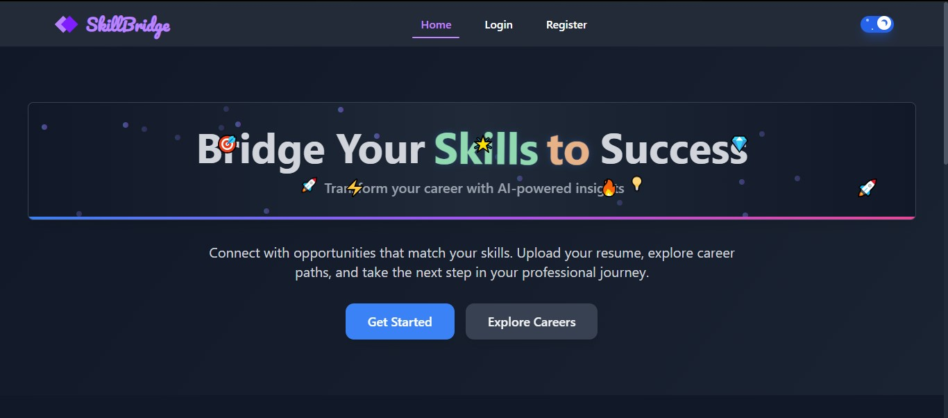
Fig 5.3.4: Landing Page

5.3.2 Registration Page
The Registration Page serves as the entry point for new users to create an account within the SkillBridge platform. It features a user-friendly form that collects essential information such as name, email, and password. The page includes input validation to ensure that the entered data meets specific criteria—for example, a valid email format and a strong password containing a mix of characters. This validation helps maintain data integrity and enhances security from the very beginning of the user experience.
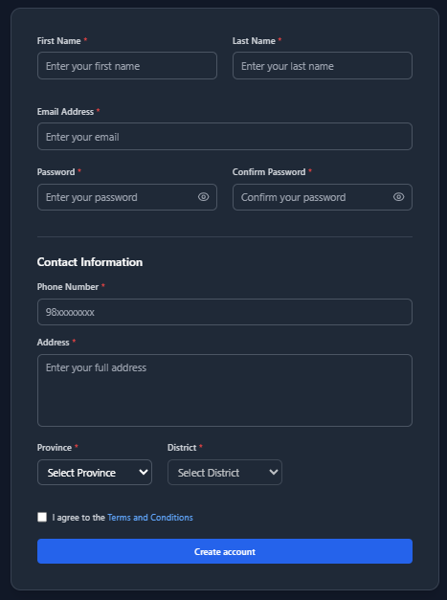
Fig 5.3.5: User registration page

5.3.3 Login Page
The Login Page is designed to authenticate existing users by verifying their email and password credentials. Upon successful validation, the system generates a secure session using JSON Web Tokens (JWT), ensuring that the user's identity is maintained throughout their interaction with the platform. This approach enhances security and allows access to protected features such as the dashboard, AI assistant, and resume analysis tools.
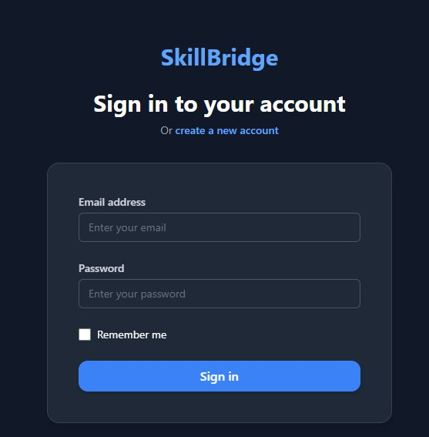
Fig 5.3.6: Login page

5.3.4 User Dashboard
The User Dashboard serves as the central hub for authenticated users within the SkillBridge system. From this interface, users can upload resumes, access previously analyzed reports, and navigate to key features such as the AI Assistant, Career Path suggestions, and Settings. It provides a clean, organized layout that allows for efficient interaction with all core functionalities, ensuring a smooth and personalized user experience
.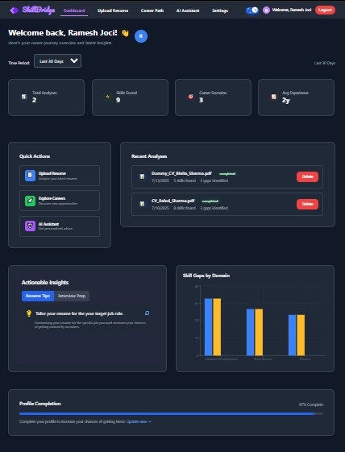
Fig 5.3.7: User dashboard

5.3.5 Resume Upload Page
The Resume Upload Page allows users to submit their resumes in PDF or text format for analysis. Once a file is selected and uploaded, it is securely sent to the backend, where Natural Language Processing (NLP) algorithms process the content to extract key information such as skills, education, and experience. This page ensures smooth file handling with proper validation and feedback to guide the user through a successful upload.
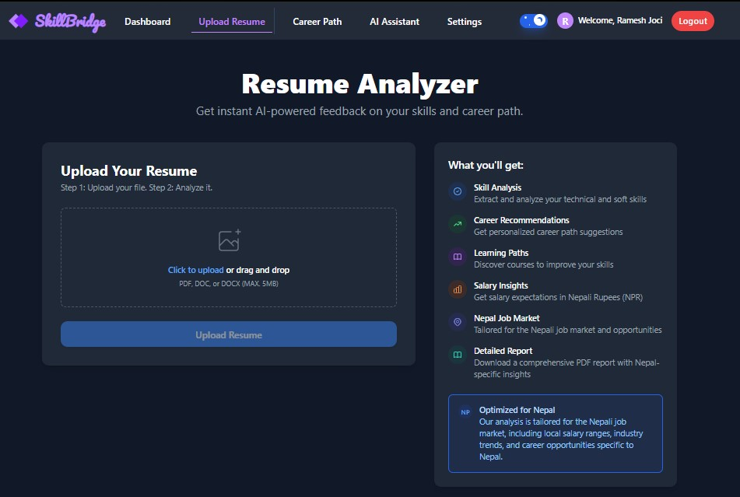
Fig 5.3.8: Resume upload page

5.3.6 Resume Analysis Result Page
Displays AI-generated feedback including:
- Strengths and weaknesses
- Suggested skills to add or remove
- Top recommended job roles
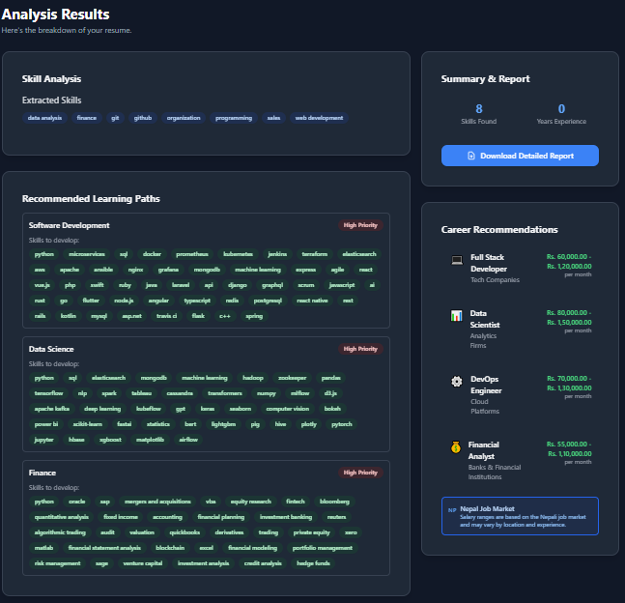
Fig 5.3.9: Resume analysis result page

5.3.7 Visual Graphs and Charts
The Visual Graphs and Charts section presents the resume analysis results through interactive visualizations using library Chart.js. These charts display key insights such as skill distribution, career domain alignment, and gap analysis in an easily understandable format. By transforming raw data into clear visuals, this feature helps users quickly grasp their strengths, weaknesses, and potential areas for improvement.
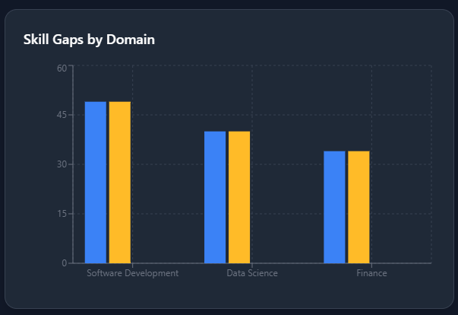
Fig 5.3.10: Graph

5.3.8 Chatbot Assistant Window
The Chatbot Assistant Window is an integrated support feature that offers real-time guidance to users. It helps them understand how to improve their resumes, suggests relevant career paths based on their profile, and answers common questions about the platform. Powered by rule-based responses or lightweight NLP logic, the chatbot enhances user experience by providing quick, interactive, and personalized assistance within the application.
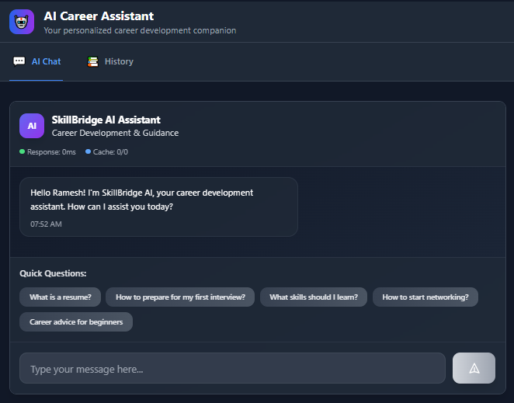
Fig 5.3.8: Ai Assistant

5.3.9 Resume History Page
The Resume History Page displays a chronological list of all resumes previously uploaded and analyzed by the user. This feature allows users to track their progress over time, compare past evaluations, and manage their resume data efficiently—all from a centralized, user-friendly interface.
. 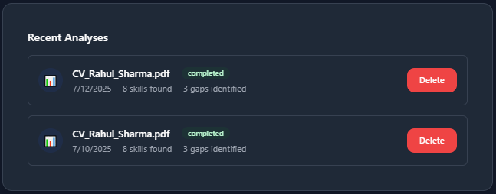
Fig 5.3.9: Resume History Page

Chapter 6: Conclusion and Future Scope

6.1 Summary
The AI-Powered Resume Analyzer System was developed to help job seekers, especially fresh graduates, analyze their resumes using Machine Learning (ML) and Natural Language Processing (NLP). The system extracts content from resumes, evaluates skills, recommends improvements, and suggests suitable career paths. It provides a modern and user-friendly platform with secure login, AI-based insights, visual reports, and a chatbot assistant. All modules were successfully integrated and tested, and the system met its primary objectives.

6.2 Limitations
Despite meeting functional requirements, the system has some current limitations:
- Only supports resume files in PDF and .docx format.
- Career suggestions are based on a predefined static dataset.
- The chatbot responds to limited predefined queries and does not support complex conversation.
- Multilingual support is not implemented.
- Integration with live job listings or LinkedIn/Indeed is not available.

6.3 Future Enhancements
The following improvements are planned for future versions:
- Train the AI model with real-time datasets from job portals.
- Enhance chatbot with Generative AI (like GPT) for smarter interaction.
- Support multiple languages and international resume formats.
- Integrate with job boards to allow direct application submission.
- Build a dashboard for admins to track system usage and analytics.

References
[1] D. Jurafsky and J. H. Martin, Speech and Language Processing, 3rd ed., Stanford University, 2020.
[2] F. Pedregosa et al., "Scikit-learn: Machine Learning in Python," Journal of Machine Learning Research, vol. 12, pp. 2825–2830, 2011.
[3] MongoDB, "The Developer Data Platform," [Online]. Available: https://www.mongodb.com/.
[4] ReactJS, "A JavaScript library for building user interfaces," [Online]. Available: https://reactjs.org/.
[5] NLTK Documentation, [Online]. Available: https://www.nltk.org/.
[6] Tailwind CSS, [Online]. Available: https://tailwindcss.com/.

Appendices
1. Appendix A: User Manual
How to Use the System:
- Visit the application and register an account.
- Log in with your credentials.
- Upload your resume (PDF or text).
- View suggestions, skill graphs, and career recommendations.
- Use the chatbot for resume-related help.
- Check your analysis history.
2 Appendix B: Installation Steps
System Requirements:
- Node.js ≥ 16.x
- Python ≥ 3.8
- MongoDB (Local or Atlas)
- Git
Steps:
- Clone the repository:
- git clone <repo-link>
- Navigate to backend directory and install dependencies:
- cd backend
- npm install
- Run the backend server:
- npm run dev
- Set up the Python AI server:
- cd ai_model
- pip install -r requirements.txt
- python app.py
- Start MongoDB locally or connect to MongoDB Atlas.
- Navigate to frontend and run React app:
- cd frontend
- npm install && npm start

